***Circuit Code:***

int button_pin = 2;

void setup() {

pinMode(button_pin, INPUT);

for(int i=8;i<=13;i++)

{

pinMode(i, OUTPUT);

}

}

void loop() {

int button_state = digitalRead(button_pin);

for(int i=8;i<=13;i++)

{

if (button_state == HIGH) {

digitalWrite(i, HIGH);

delay(10);

digitalWrite(i, LOW);

delay(10);}

else{

digitalWrite(i, HIGH);

delay(1000);

digitalWrite(i, LOW);

delay(1000); }

}

}

***Circuit diagram:***

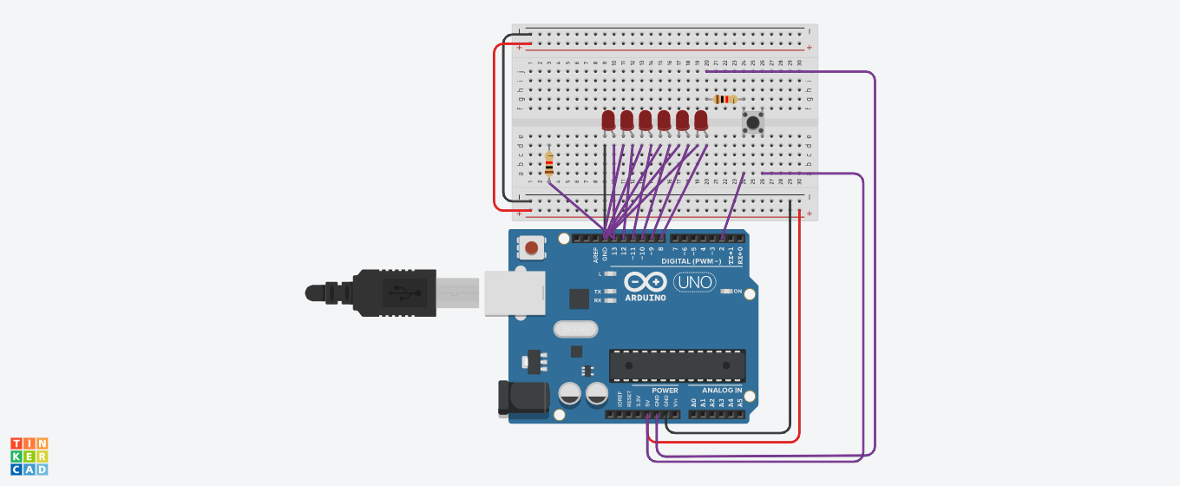

***Learning Outcomes :***

1. Learn to create more patterns.
2. Explore more about these circuit elements.
3. More angage in learning and researche process.
4. Allow us to identify and transfer existing ideas into new contexts and applications.

***Precautions :***

1. Connections should be tight.
2. Have the proper knowledge about all the circuits elements.
3. There should be no problem in any circuit element.
4. All the circuit elements must be first checked by the multimeter.

***Theory:***

A **light-emitting diode** (**LED**) is a [semiconductor](https://en.wikipedia.org/wiki/Semiconductor) [light source](https://en.wikipedia.org/wiki/Light_source) that emits light when [current](https://en.wikipedia.org/wiki/Electric_current) flows through it. [Electrons](https://en.wikipedia.org/wiki/Electron) in the semiconductor recombine with [electron holes](https://en.wikipedia.org/wiki/Electron_hole), releasing energy in the form of [photons](https://en.wikipedia.org/wiki/Photon). The color of the light (corresponding to the energy of the photons) is determined by the energy required for electrons to cross the [band gap](https://en.wikipedia.org/wiki/Band_gap) of the semiconductor.[[5]](https://en.wikipedia.org/wiki/Light-emitting_diode#cite_note-5) White light is obtained by using multiple semiconductors or a layer of light-emitting phosphor on the semiconductor device.

LEDs have many advantages over incandescent light sources, including lower energy consumption, longer lifetime, improved physical robustness, smaller size, and faster switching. LEDs are used in applications as diverse as [aviation lighting](https://en.wikipedia.org/wiki/Navigation_light#Aviation_navigation_lights), [automotive headlamps](https://en.wikipedia.org/wiki/Automotive_lighting#Light_emitting_diodes_(LED)), advertising, [general lighting](https://en.wikipedia.org/wiki/Lighting), [traffic signals](https://en.wikipedia.org/wiki/Traffic_signal), camera flashes, lighted wallpaper, [plant growing light](https://en.wikipedia.org/wiki/Grow_light), and medical devices.

Unlike a [laser](https://en.wikipedia.org/wiki/Laser), the light emitted from an LED is neither spectrally [coherent](https://en.wikipedia.org/wiki/Coherence_(physics)) nor even highly [monochromatic](https://en.wikipedia.org/wiki/Monochromatic). However its [spectrum](https://en.wikipedia.org/wiki/Spectrum#Electromagnetic_spectrum) is sufficiently narrow that it appears to the [human eye](https://en.wikipedia.org/wiki/Color_vision) as a pure ([saturated](https://en.wikipedia.org/wiki/Colorfulness#Saturation)) color. Nor, unlike most lasers, is its radiation [spatially coherent](https://en.wikipedia.org/wiki/Coherence_(physics)#Spatial_coherence), so that it cannot approach the very high [brightnesses](https://en.wikipedia.org/wiki/Radiance) characteristic of lasers.

A Push Button is a type of switch work on a simple mechanism called “Push-to-make”. Initially, it remains in **off state or normally open state** but when it is pressed, it allows the current to pass through it or we can say **it makes the circuit when pressed**. Normally their body is made up of plastic or metal in some types.

Push Button structure has four legs, two on one side and other two on another side. So, we can operate two lines of the circuit by single Push Button. Two legs on both the sides are internally connected as shown in the figure above.

The one leg of Push Button is connected to 5v supply and the other one is connected with LED via the resistor, as shown in circuit diagram. Initially, Push Button does not allow the current to flow through it, but when it is pressed it completes the circuit and LED will start to glow. The current will pass till the button is pressed, as soon as we release it, the LED will be turned off as push-button breaks the circuit and stop the supply. It can be clearly understood by the animated circuit diagram above.